Reference

Prediction 0 1

0 51 47

1 2113 45053

Accuracy : 0.9543

95% CI : (0.9524, 0.9562)

No Information Rate : 0.9542

P-Value [Acc > NIR] : 0.4706

Kappa : 0.0413

Mcnemar's Test P-Value : <2e-16

Sensitivity : 0.99896

Specificity : 0.02357

Pos Pred Value : 0.95520

Neg Pred Value : 0.52041

Prevalence : 0.95421

Detection Rate : 0.95322

Detection Prevalence : 0.99793

Balanced Accuracy : 0.51126

'Positive' Class : 1

prediction from a rank-deficient fit may be misleadingConfusion Matrix and Statistics

Reference

Prediction 0 1

0 65 73

1 2099 45027

Accuracy : 0.954

95% CI : (0.9521, 0.9559)

No Information Rate : 0.9542

P-Value [Acc > NIR] : 0.5755

Kappa : 0.0513

Mcnemar's Test P-Value : <2e-16

Sensitivity : 0.99838

Specificity : 0.03004

Pos Pred Value : 0.95546

Neg Pred Value : 0.47101

Prevalence : 0.95421

Detection Rate : 0.95267

Detection Prevalence : 0.99708

Balanced Accuracy : 0.51421

'Positive' Class : 1

prediction from a rank-deficient fit may be misleadingConfusion Matrix and Statistics

Reference

Prediction 0 1

0 84 105

1 2080 44995

Accuracy : 0.9538

95% CI : (0.9518, 0.9556)

No Information Rate : 0.9542

P-Value [Acc > NIR] : 0.6829

Kappa : 0.0645

Mcnemar's Test P-Value : <2e-16

Sensitivity : 0.99767

Specificity : 0.03882

Pos Pred Value : 0.95582

Neg Pred Value : 0.44444

Prevalence : 0.95421

Detection Rate : 0.95199

Detection Prevalence : 0.99600

Balanced Accuracy : 0.51824

'Positive' Class : 1

prediction from a rank-deficient fit may be misleadingConfusion Matrix and Statistics

Reference

Prediction 0 1

0 117 173

1 2047 44927

Accuracy : 0.953

95% CI : (0.9511, 0.9549)

No Information Rate : 0.9542

P-Value [Acc > NIR] : 0.8928

Kappa : 0.0855

Mcnemar's Test P-Value : <2e-16

Sensitivity : 0.99616

Specificity : 0.05407

Pos Pred Value : 0.95642

Neg Pred Value : 0.40345

Prevalence : 0.95421

Detection Rate : 0.95055

Detection Prevalence : 0.99386

Balanced Accuracy : 0.52512

'Positive' Class : 1

prediction from a rank-deficient fit may be misleadingConfusion Matrix and Statistics

Reference

Prediction 0 1

0 153 283

1 2011 44817

Accuracy : 0.9515

95% CI : (0.9495, 0.9534)

No Information Rate : 0.9542

P-Value [Acc > NIR] : 0.9978

Kappa : 0.1039

Mcnemar's Test P-Value : <2e-16

Sensitivity : 0.9937

Specificity : 0.0707

Pos Pred Value : 0.9571

Neg Pred Value : 0.3509

Prevalence : 0.9542

Detection Rate : 0.9482

Detection Prevalence : 0.9908

Balanced Accuracy : 0.5322

'Positive' Class : 1

prediction from a rank-deficient fit may be misleadingConfusion Matrix and Statistics

Reference

Prediction 0 1

0 240 464

1 1924 44636

Accuracy : 0.9495

95% CI : (0.9475, 0.9514)

No Information Rate : 0.9542

P-Value [Acc > NIR] : 1

Kappa : 0.1482

Mcnemar's Test P-Value : <2e-16

Sensitivity : 0.9897

Specificity : 0.1109

Pos Pred Value : 0.9587

Neg Pred Value : 0.3409

Prevalence : 0.9542

Detection Rate : 0.9444

Detection Prevalence : 0.9851

Balanced Accuracy : 0.5503

'Positive' Class : 1

prediction from a rank-deficient fit may be misleadingConfusion Matrix and Statistics

Reference

Prediction 0 1

0 328 822

1 1836 44278

Accuracy : 0.9438

95% CI : (0.9416, 0.9458)

No Information Rate : 0.9542

P-Value [Acc > NIR] : 1

Kappa : 0.1716

Mcnemar's Test P-Value : <2e-16

Sensitivity : 0.9818

Specificity : 0.1516

Pos Pred Value : 0.9602

Neg Pred Value : 0.2852

Prevalence : 0.9542

Detection Rate : 0.9368

Detection Prevalence : 0.9757

Balanced Accuracy : 0.5667

'Positive' Class : 1

prediction from a rank-deficient fit may be misleadingConfusion Matrix and Statistics

Reference

Prediction 0 1

0 486 1558

1 1678 43542

Accuracy : 0.9315

95% CI : (0.9292, 0.9338)

No Information Rate : 0.9542

P-Value [Acc > NIR] : 1.00000

Kappa : 0.1952

Mcnemar's Test P-Value : 0.03645

Sensitivity : 0.9655

Specificity : 0.2246

Pos Pred Value : 0.9629

Neg Pred Value : 0.2378

Prevalence : 0.9542

Detection Rate : 0.9213

Detection Prevalence : 0.9568

Balanced Accuracy : 0.5950

'Positive' Class : 1

prediction from a rank-deficient fit may be misleadingConfusion Matrix and Statistics

Reference

Prediction 0 1

0 772 3631

1 1392 41469

Accuracy : 0.8937

95% CI : (0.8909, 0.8965)

No Information Rate : 0.9542

P-Value [Acc > NIR] : 1

Kappa : 0.1851

Mcnemar's Test P-Value : <2e-16

Sensitivity : 0.9195

Specificity : 0.3567

Pos Pred Value : 0.9675

Neg Pred Value : 0.1753

Prevalence : 0.9542

Detection Rate : 0.8774

Detection Prevalence : 0.9068

Balanced Accuracy : 0.6381

'Positive' Class : 1

prediction from a rank-deficient fit may be misleadingConfusion Matrix and Statistics

Reference

Prediction 0 1

0 1389 11937

1 775 33163

Accuracy : 0.731

95% CI : (0.727, 0.735)

No Information Rate : 0.9542

P-Value [Acc > NIR] : 1

Kappa : 0.1092

Mcnemar's Test P-Value : <2e-16

Sensitivity : 0.7353

Specificity : 0.6419

Pos Pred Value : 0.9772

Neg Pred Value : 0.1042

Prevalence : 0.9542

Detection Rate : 0.7017

Detection Prevalence : 0.7181

Balanced Accuracy : 0.6886

'Positive' Class : 1

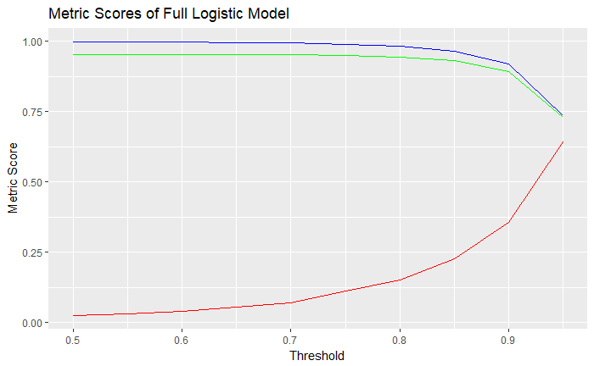

|  |
| --- |
|  |
| **sequence**  <dbl> | **acc**  <dbl> | **sens**  <dbl> | **spec**  <dbl> |  |
| 0.50 | 0.9542993 | 0.9989579 | 0.02356747 |  |
| 0.55 | 0.9540454 | 0.9983814 | 0.03003697 |  |
| 0.60 | 0.9537703 | 0.9976718 | 0.03881701 |  |
| 0.65 | 0.9530298 | 0.9961641 | 0.05406654 |  |
| 0.70 | 0.9514641 | 0.9937251 | 0.07070240 |  |
| 0.75 | 0.9494753 | 0.9897118 | 0.11090573 |  |
| 0.80 | 0.9437627 | 0.9817738 | 0.15157116 |  |
| 0.85 | 0.9315335 | 0.9654545 | 0.22458410 |  |
| 0.90 | 0.8937246 | 0.9194900 | 0.35674677 |  |
| 0.95 | 0.7310427 | 0.7353215 | 0.64186691 |  |